Indian Institute of Science Education and Research Kolkata
Mid-Semester Quiz - CH-1202

Date: 13-03-2019 Marks: 20 (Answer all) Time: 60 minutes

- a) Which instrument was used to determine the hydrolysis constant of anilinium hydrochloride salt? What other instrument you could have used to perform this same experiment? b) Instead of anilinium hydrochloride, if sodium acetate was used, what would be the relationship between K_{h} with K_{w}. Derive this relation with respect to dissociation constant [1+ 2 mark]
- a) What was the role of the calomel electrode during the experiment for determination of hydrolysis constant of anilinium hydrochloride. b) For the experiment for determination of K_{sp}, ΔG⁰, ΔH⁰ and ΔS⁰, why it was recommended to boil the distilled water before adding the solid calcium hydroxide for the high-temperature measurement? c) If you did not boil, show the reaction which could have caused an interference with the final results? [2.0+1.5+1.5 mark]
- The structure of cysteine at pH 7 is:
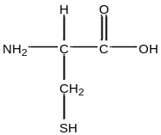
The pK_{a} values for the α-carboxylic acid and the amine groups are 1.092 and 10.78, respectively. The pK_{a} for the titratable –SH side chain is 8.33. Calculate the pI of cysteine showing the structures of the amino acid at the different pH regions in course of the titration with a strong alkali solution. [2+ 2 mark]
- The absorption spectra of oxy and deoxy form of hemoglobin is given below. Suggest a wavelength at which you will monitor the absorbance/transmittance to selectively detect the concentration of deoxy- form and justify your choice of wavelength. If you are obtaining a % transmittance of 78 at 610 nm, (extinction coefficient is 1.2 x 10⁴ L cm⁻¹ M⁻¹), calculate the concentration of the deoxy form in your sample. [2+ 2 mark]

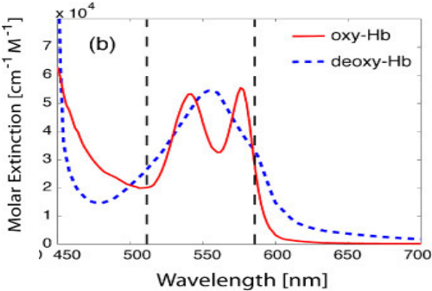

- Consider a classic iodine clock reaction between iodide ions and persulfate ions [4 mark]
2I⁻ + S₂O₈²⁻ → 2SO₄²⁻ + I₂
The following data was collected for different initial concentration of iodide and persulfate ions
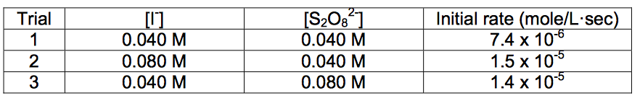
Compare the trials 1 and 2: How did the concentration of iodide ions change in these two trials and how did the rate change accordingly. What is the reaction order for iodide ions.

